Download this file. After you complete all the work, upload it in blackboard under Assignment 5.

Design a todoapp with the following user interfaces

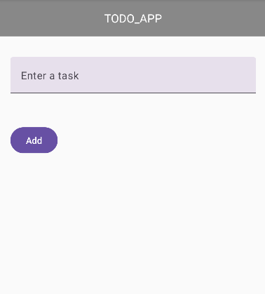 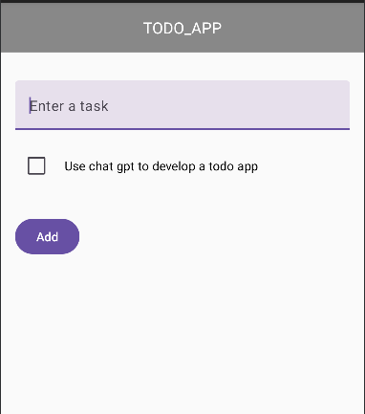 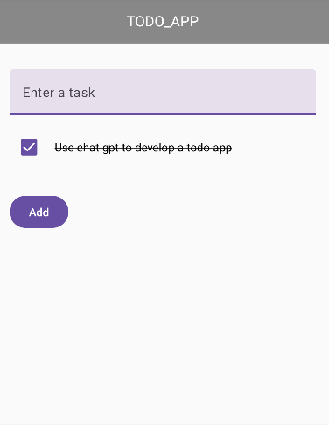

Describe this app to chatgpt and ask it to write Android Compose code

Enter your prompt here

ı need a one page to do app in kotlin composable ı should enter a task with add button and task should have check box too and when ıts clicked the task should with a line drawn across it

Correct all errors. Once the program is working as expected, run the program, take screen captures of the outputs (as above) and paste them here.

Put the program with readme file explaining the problem and showing output screens to your github (https://github.com/YarenTekdemir/mobil1.yaren.tekdemir.200704309.git

). Paste the link here.

